**"Day 5 - Testing and Backend Refinement - [Your NIKE E-COMMERCE]"**

1. **Functional Testing**
2. **Error Handling**
3. **API Status**

***https://template-03-api.vercel.app/api/products***

**1: Functional Testing**

**Product listing:products are displayed correctly.**

**Dynamic routing: individual product detail pages load correctly.**

**Testing tool(thunder Client) : For API response testing{status 200}**

**=**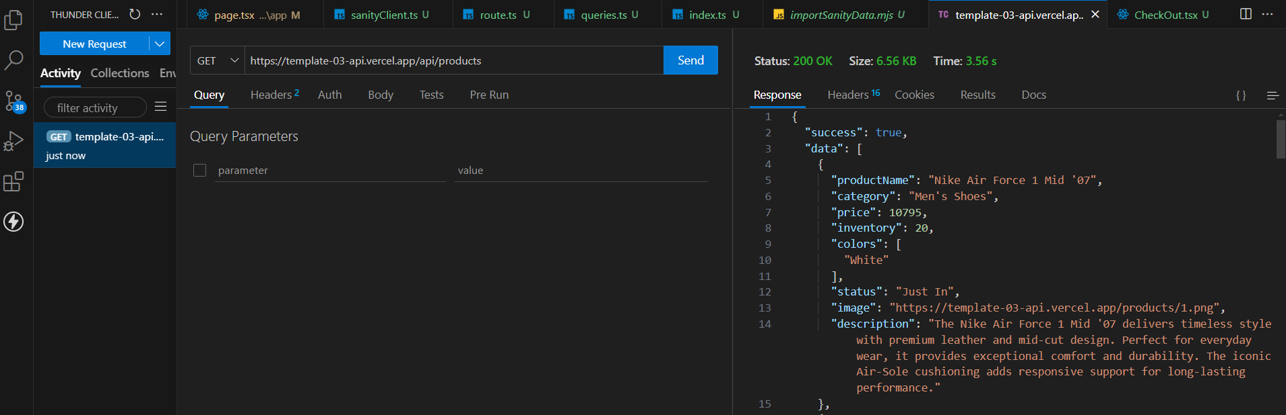

**Testing report**

|  |  |  |  |  |  |  |  |  |
| --- | --- | --- | --- | --- | --- | --- | --- | --- |
| Test Case ID | Test Case Description | Test Steps | Expected Result | Actual Result | Status | Severity Level | Assigned To | Remarks |
| TC001 | Validate product listing page | Open product page > Verify products | Products displayed correctly | Products displayed correctly | Passed | Low | - | No issues found |
| TC002 | Test API error handling | Disconnect API > Refresh page | Show fallback UI with error message | Error message shown | Passed | Medium | - | Handled gracefully |
| TC003 | Check cart functionality | Add product to cart > Verify cart contents | Cart updates with added product | Cart updates as expected | Passed | High | - | Works as expected |
| TC004 | Ensure responsiveness on mobile | Resize browser window > Check layout | Layout adjusts properly to screen size | Responsive layout working as intended | Passed | Medium | - | Test successful |

***Performance optimization***

